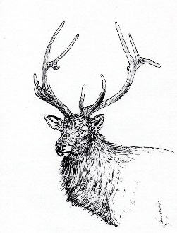**LITTLE RIVER BAND OF OTTAWA INDIANS**

**2025 ELK PERMIT APPLICATION**

*Applications must be postmarked by:*

**May 23, 2025 at 5:00pm**

The lottery drawing for permits, and alternate hunters will be held in June at a time and location determined by the LRBOI Natural Resources Commission. **You do not need to be present at the drawing to be selected.** Selected applicants will be contacted by the LRBOI Natural Resources Department using the information provided below, please ensure it is accurate. In the event the NRD is unable to contact a successful applicant, that permit will be offered to the next alternate hunter selected at the drawing.

***If you have questions or comments, contact:***

LRBOI Natural Resources Department 231-723-1594

Sean Hollowell, Wildlife Division Manager

seanhollowell@lrboi-nsn.gov

**NAME:** ________________________________________________________________________________________________ **TRIBAL ID #:** __________________________

**ELDER?:** _______YES _________NO **STREET ADDRESS:** _________________________________________________________________________________

**CITY:** ______________________________________________________________________________ **STATE:** ___________ **ZIP CODE:** _______________________

**DAYTIME PHONE:** ________________________ **CELL:** ______________________________ **EMAIL:** __________________________________________________

**PREFERRED CONTACT METHOD:** _________EMAIL _________PHONE _________POSTAL MAIL

***Return Application to:***

LRBOI Natural Resources Department

Mailing Address: 2608 Government Center Drive, Manistee, MI 49660

Office Address: 310 9th Street, Manistee, MI 49660